First Insights: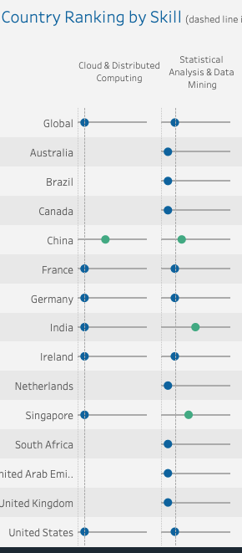

The first insight I found is that people are more focusing on cloud & distributed computing and statistical Analysis and Data Mining across the globe. In the dashboard, focusing on the Cloud and distributed computing column, we are able to see that it’s the top skill set for people in most of the countries. Following closely on statistical Analysis and Data Mining, which came second in average.

Second Insights

India has a relatively high demand in User Interface design. From the list, if we focus on the row “India” and column “User Interface Design”, it is the second top skills, which is higher than the global average (5).

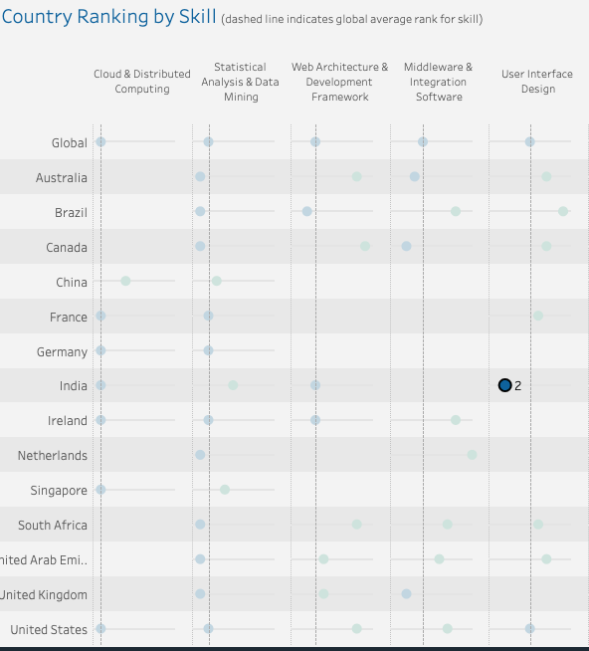

Third Insight:

In China, people are more focused on Network and Information Security. From the dashboard, the related results can be found by the column of Network and Information Security and the row “China”. We can see it has 2nd rank on it for Network and Information Security and it’s higher than the global average rank.

